LAB NO.: 2

INTRODUCTION TO LINUX COMMANDS

1. lscpu
- Function: Displays CPU architecture information.
- Use Case: View processor details like cores, threads, model.
- Options:
  - --all – Show all CPUs.
  - --extended – Detailed table format.
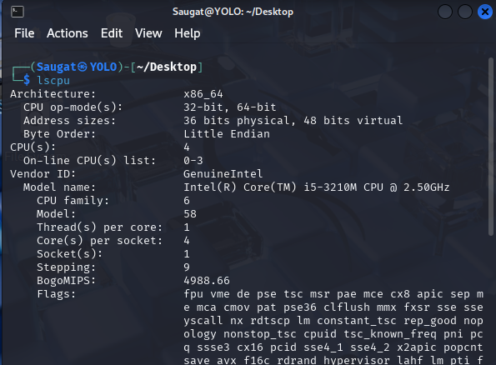
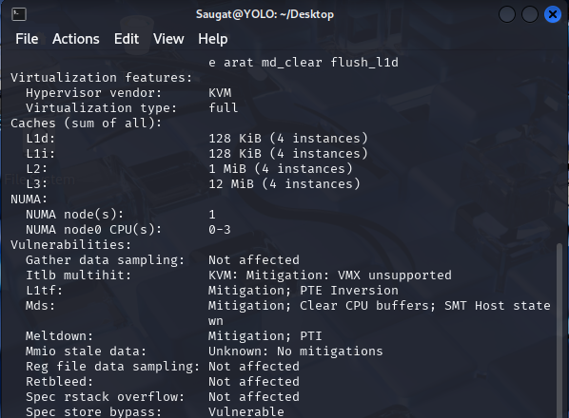
2. lshw
- Function: Lists detailed hardware configuration.
- Use Case: View complete system hardware info (CPU, RAM, devices).
- Options:
  - -short – Brief summary.
  - -class [class] – Filter by hardware class (e.g., memory, processor).
  - -html – Output in HTML format.
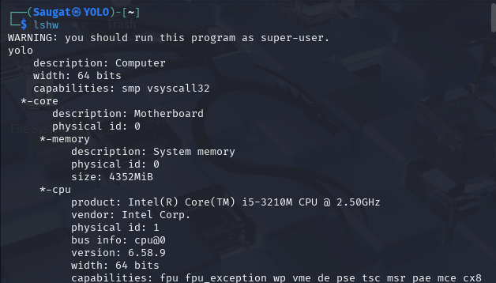
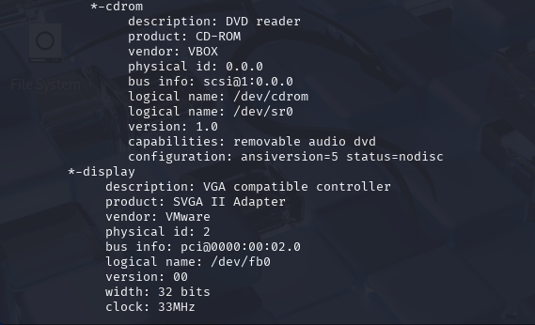
3. hwinfo
- Function: Provides detailed hardware information.
- Use Case: Detect and view all system hardware.
- Options:
  - --short – Show brief output.
  - --cpu, --memory – Specific hardware class info.
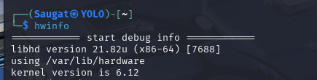
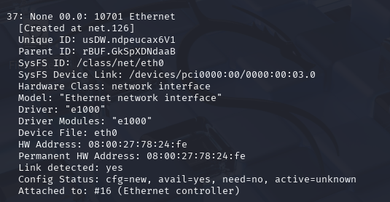
4. lspci
- Function: Lists PCI buses and devices.
- Use Case: Identify connected hardware (GPU, network cards).
- Options:
  - -v – Verbose.
  - -nn – Show numeric IDs.
  - -k – Show kernel drivers used.
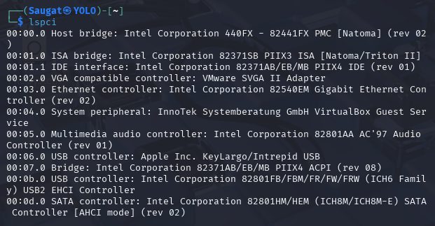
5. lsscsi
- Function: Lists SCSI/SATA devices.
- Use Case: View connected storage devices.
- Options:
  - -s – Show size.
  - -v – Verbose output.
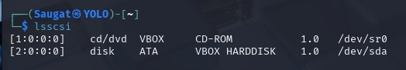
6. lsusb
- Function: Lists USB devices.
- Use Case: Check connected USB devices.
- Options:
  - -v – Verbose info.
  - -t – Tree view.
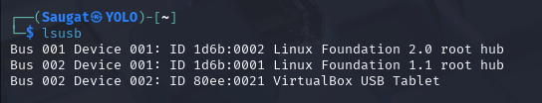
7. inxi
- Function: Displays full system information in a human-readable format.
- Use Case: Summary of hardware, software, and drivers.
- Options:
  - -Fxz – Full, with filters and no sensitive data.
  - -C, -S, -G – Specific info: CPU, System, Graphics.
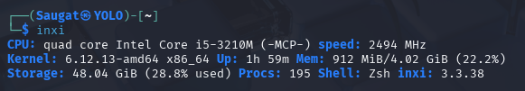
8. lsblk
- Function: Lists block devices (like partitions, disks).
- Use Case: See how storage is organized.
- Options:
  - -f – Show filesystem info.
  - -o NAME,SIZE,MOUNTPOINT – Custom columns.
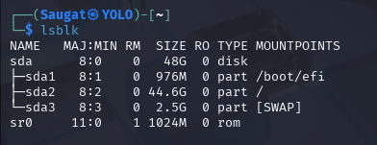
9. df (Disk Free)
- Function: Shows disk space usage.
- Use Case: Check available and used disk space.
- Options:
  - -h – Human-readable format.
  - -T – Show filesystem type.
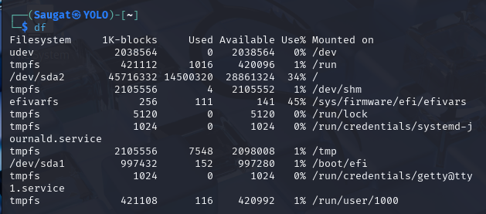
10. fdisk
- Function: Partition management tool.
- Use Case: View and edit disk partitions.
- Options:
  - -l – List all partitions.
  - Interactively: n (new), d (delete), p (print), w (write).
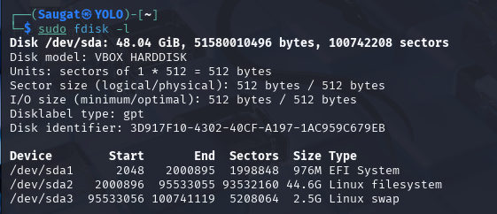
11. free
- Function: Shows memory usage (RAM + swap).
- Use Case: Check available and used memory.
- Options:
  - -h – Human-readable.
  - -m, -g – Show in MB or GB.
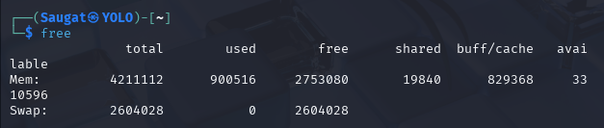
12. top
- Function: Live system monitoring (processes, memory, CPU).
- Use Case: Monitor running tasks and performance.
- Options:
  - Press M (sort by memory), P (by CPU).
  - Use -n [count] to limit updates.
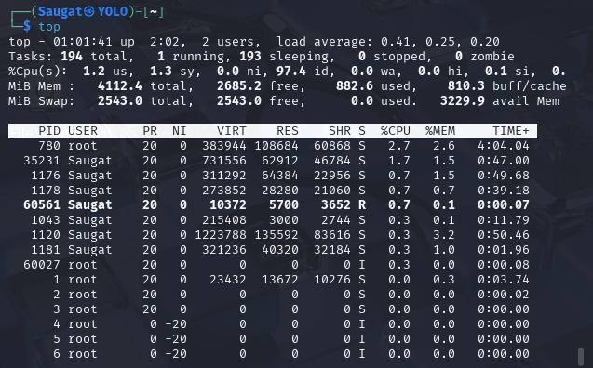
13. /proc/cpuinfo
- Function: Shows detailed CPU info from a virtual file.
- Use Case: Check processor specs and core details.
- Command: cat /proc/cpuinfo
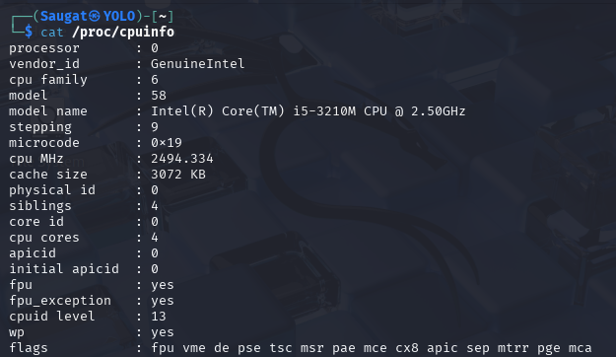
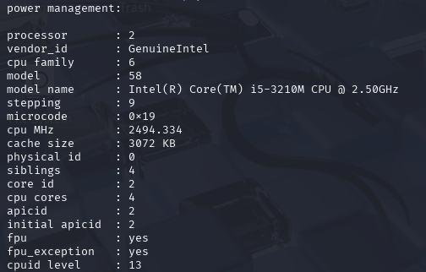
14. /proc/meminfo
- Function: Shows detailed RAM statistics.
- Use Case: Analyze memory state.
- Command: cat /proc/meminfo
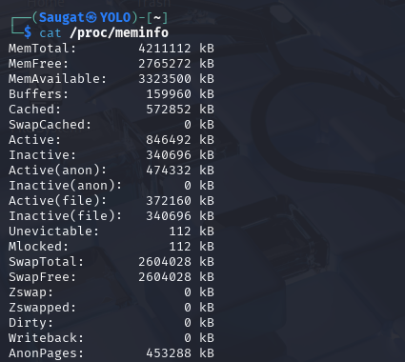
15. uname
- Function: Displays system information.
- Use Case: Identify OS type and kernel version.
- Options:
  - -a – All system info.
  - -r – Kernel version.
  - -n – Hostname.
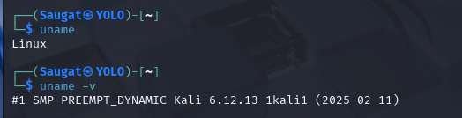
16. id
- Function: Shows current user ID and group info.
- Use Case: Check user identity and privileges.
- Options:
  - -u – Show user ID.
  - -g – Show group ID.
  - -Gn – Show all groups (names).
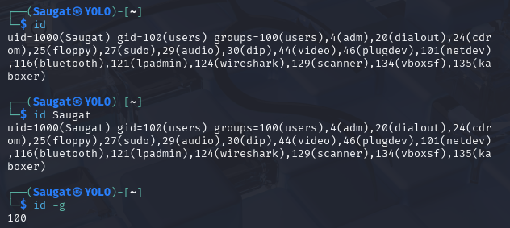
17. init
- Function: Initializes system runlevels (older systems).
- Use Case: Switch between runlevels (e.g., reboot, shutdown).
- Syntax: init [runlevel]
- Note: Modern systems use systemd (systemctl).

18. apt
- Function: Modern package management interface (Debian/Ubuntu).
- Use Case: Install, update, upgrade packages.
- Options:
  - apt update – Update package list.
  - apt upgrade – Upgrade all upgradable packages.
  - apt install [pkg] – Install package.
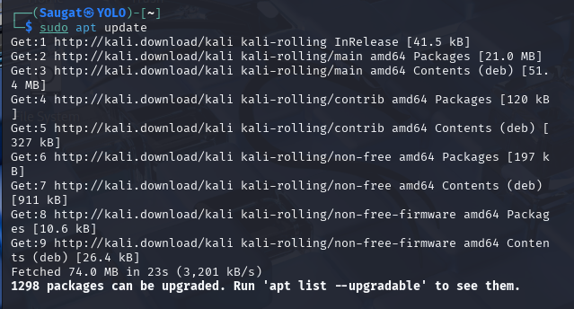
19. apt-get
- Function: Lower-level tool for package management (older but powerful).
- Use Case: Scriptable package operations.
- Options:
  - apt-get install [pkg] – Install.
  - apt-get remove [pkg] – Uninstall.
  - apt-get autoremove – Remove unused packages.
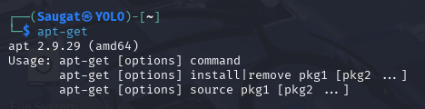
20. sudo
- Function: Run commands as another user (default: root).
- Use Case: Execute privileged tasks.
- Syntax: sudo [command]
- Options:
  - -i – Open a root shell.
  - -u [user] – Run as specific user.
  - sudo !! – Re-run last command with sudo.
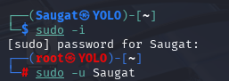

Conclusion
In this lab, we explored 20 essential Linux commands used for system monitoring, hardware information, file management, and package control. These commands form the foundational toolkit for any Linux user or administrator, providing insight into system performance (top, free, df), hardware details (lscpu, lshw, lsusb, lspci), and identity or environment (uname, id).
We also learned to manage system packages effectively using apt, apt-get, and elevated permissions through sudo, which are critical for system maintenance and security. Understanding /proc files (cpuinfo, meminfo) further deepened our knowledge of how Linux internally stores system information.
Overall, this lab reinforced the importance of mastering basic and intermediate Linux commands to efficiently navigate, diagnose, and manage a Linux environment, which is crucial in both academic and professional IT settings.

